

|  |  |  |  |  |  |  |
| --- | --- | --- | --- | --- | --- | --- |
|  | | | | |  | |
|  |  |  |  |  |  |  |
|  |  |  |  |  |  |  |
|  |  |  |  |  |  |  |
|  |  |  |  |  |  |  |
|  |  |  |  |  |  |  |
|  |  |  |  |  |  |  |
|  |  |  |  |  |  |  |
|  |  |  |  |  |  |  |

|  |  |  |
| --- | --- | --- |
|  | | |
|  |  |  |
|  |  |  |
|  |  |  |

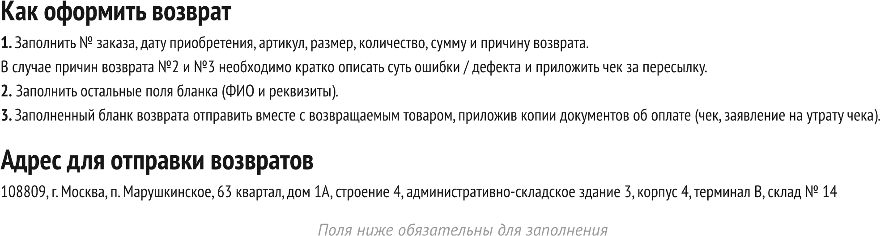

г. Екатеринбург, проспект Академика Сахарова, д. 29 (ПВЗ СДЕК).  
Получатель: ИП Клопова Марина Александровна, тел.: 8-962-313-13-33.

|  |
| --- |
|  |
|  |